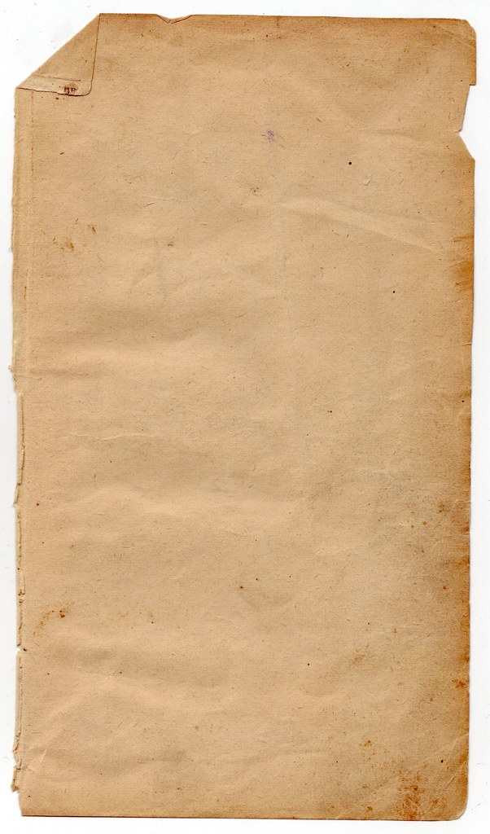

**Recipe Book Codes**

1)If You don’t want to fall Count the windows on the wall

2) If you want nothing to fear count the number of shades on the

chandelier

`

3)if you don’t want to meet the fate of the swords that heroes wield look on the wall and count the number of the royal kings’ shields

4) If you don’t want to take a long long nap count the number of countries that are on the map

wield

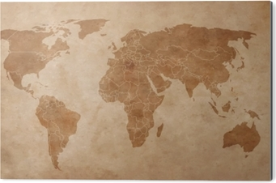

Sweden

India

Madagascar

Spain

Mexico

Brazil

Russia

If



**s**

**T**

**R**

**A**

**T**



**E**

**H**

**T**



**C**

**L**

**O**

**C**

**K**